Stopping and Starting Oracle XE

At some point you may want to stop and/or start the Oracle XE database. You may need to "bounce" the database. Or you may want to stop the database for a period of time to give more resources to other applications (databases are memory intensive). The page describes how to do that.

**Step #1**

Find the "Control Panel" in Windows. This is located in different place in different versions of Windows, but it is always located somewhere on the "Start" menu.

**Step #2**

Find the "Administrative Tools" folder. Sometime this is on the main part of the control panel. Other times you have to click on "System and Security" first.

**Step #3**

Double click on "Services".

**Step #4**

Scroll to find the entries for "OracleServiceXE" and "OracleXETNSListener". Right click on either one and then click "stop" or "start". Note that **both** of these services must be running for Oracle XE to work.

[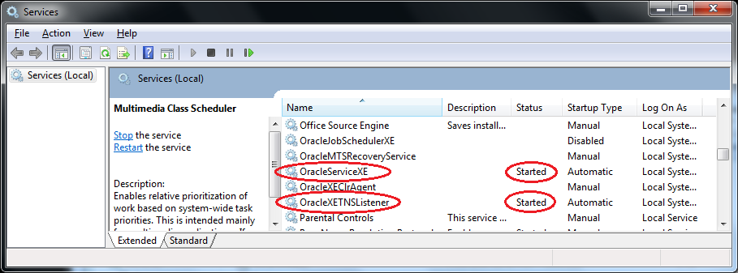](http://www.thatlink.com/Classes/cis2720sp14/images/OracleXEServices.png)

**Optional: Change Startup Type**

You can also change whether or not Oracle XE starts automatically when you boot your computer. Right click on one of the two services, and then click properties. To have the service start automatically when booting change the startup type to "Automatic". If you do not want Oracle to start when booting change the startup type to "Disabled". Remember that **both** of the services must be running for Oracle XE to work.

[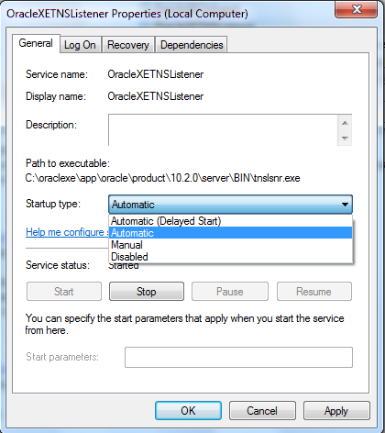](http://www.thatlink.com/Classes/cis2720sp14/images/OracleServicesOptional.png)